**BUS LOCATOR SYSTEM**

**EXPERIMENT-12**

**12.1 Introduction of Testing**

**Introduction:** Software Testing is a method to assess the functionality of the software program. The process checks whether the actual software matches the expected requirements and ensures the software is bug-free. The purpose of software testing is to identify the errors, faults, or missing requirements in contrast to actual requirements. It mainly aims at measuring the specification, functionality, and performance of a software program or application.

**Software testing can be divided into two steps:**

* **Verification:** It refers to the set of tasks that ensure that the software correctly implements a specific function. It means “Are we building the right product?”
* **Validation:** It refers to a different set of tasks that ensure that the software that has been built is traceable to customer requirements. It means “Are we building the right product?”

**Importance of Software Testing:**

* **Defects can be identified early:** Software testing is important because if there are any bugs they can be identified early and can be fixed before the delivery of the software.
* **Improves quality of software:** Software Testing uncovers the defects in the software, and fixing them improves the quality of the software.
* **Increased customer satisfaction:** Software testing ensures reliability, security, and high performance which results in saving time, costs, and customer satisfaction.
* **Helps with scalability:** Software testing type non-functional testing helps to identify the scalability issues and the point where an application might stop working.
* **Saves time and money:** After the application is launched it will be very difficult to trace and resolve the issues, as performing this activity will incur more costs and time. Thus, it is better to conduct software testing at regular intervals during software development.

**Need for Software Testing:**

Software bugs can cause potential monetary and human loss. There are many examples in history that clearly depicts that without the testing phase in software development lot of damage was incurred. Below are some examples:

* **1985:** Canada’s Therac-25 radiation therapy malfunctioned due to a software bug and resulted in lethal radiation doses to patients leaving 3 injured and 3 people dead.
* **1994:** China Airlines Airbus A300 crashed due to a software bug killing 264 people.
* **1996:** A software bug caused U.S. bank accounts of 823 customers to be credited with 920 million US dollars.
* **1999:** A software bug caused the failure of a $1.2 billion military satellite launch.
* **2015:** A software bug in fighter plan F-35 resulted in making it unable to detect targets correctly.
* **2015:** Bloomberg terminal in London crashed due to a software bug affecting 300,000 traders on the financial market and forcing the government to postpone the 3bn pound debt sale.
* Starbucks was forced to close more than 60% of its outlet in the U.S. and Canada due to a software failure in its POS system.
* Nissan cars were forced to recall 1 million cars from the market due to a software failure in the car’s airbag sensory detectors.

**Software Testing can be broadly classified into 3 types:**

* Functional testing: It is a type of software testing that validates the software systems against the functional requirements. It is performed to check whether the application is working as per the software’s functional requirements or not. Various types of functional testing are Unit testing, Integration testing, System testing, Smoke testing, and so on.
* Non-functional testing: It is a type of software testing that checks the application for non-functional requirements like performance, scalability, portability, stress, etc.
* Maintenance testing: It is the process of changing, modifying, and updating the software to keep up with the customer’s needs. It involves regression testing that verifies that recent changes to the code have not adversely affected other previously working parts of the software.

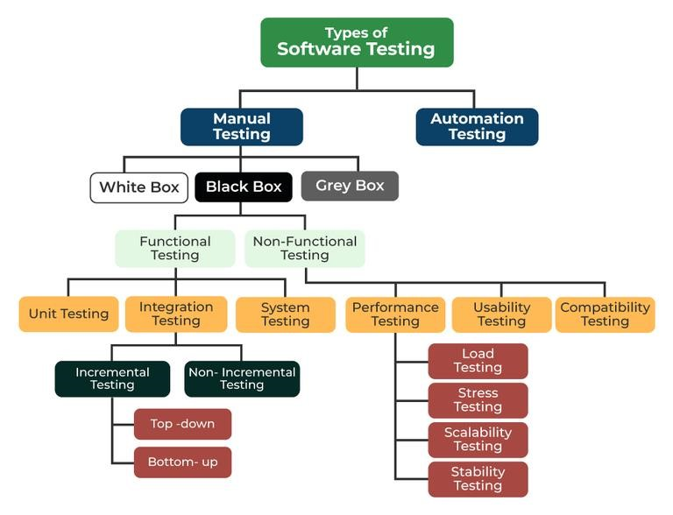

DIFFERENT TYPES OF TESTING

Apart from the above classification software testing can be further divided into 2 more ways of testing:

* Manual testing: It includes testing software manually, i.e., without using any automation tool or script. In this type, the tester takes over the role of an end-user and

tests the software to identify any unexpected behaviour or bug. There are different stages for manual testing such as unit testing, integration testing, system testing, and user acceptance testing. Testers use test plans, test cases, or test scenarios to test software to

ensure the completeness of testing. Manual testing also includes exploratory testing, as testers explore the software to identify errors in it.

* Automation testing: It is also known as Test Automation, is when the tester writes scripts and uses another software to test the product. This process involves the automation of a manual process.

Automation Testing is used to re-run the test scenarios quickly and repeatedly, that were performed manually in manual testing.

Apart from Regression testing, Automation testing is also used to test the application from a load, performance, and stress point of view. It increases the test coverage, improves accuracy, and saves time and money when compared to manual testing.

Different Types of Software Testing Techniques

Software testing techniques can be majorly classified into two categories:

* Black box Testing: Testing in which the tester doesn’t have access to the source code of the software and is conducted at the software interface without any concern with the internal logical structure of the software known as black-box testing.
* White box Testing: Testing in which the tester is aware of the internal workings of the product, has access to its source code, and is conducted by making sure that all internal operations are performed according to the specifications is known as white box testing.
* Grey Box Testing: Testing in which the testers should have knowledge of implementation, however, they need not be experts.

**Benefits of testing:**

* Product quality: Testing ensures the delivery of a high-quality product as the errors are discovered and fixed early in the development cycle.
* Customer satisfaction: Software testing aims to detect the errors or vulnerabilities in the software early in the development phase so that the detected bugs can be fixed

before the delivery of the product. Usability testing is a type of software testing that checks the application for how easily usable it is for the users to use the application.

* Cost-effective: Testing any project on time helps to save money and time for the long term. If the bugs are caught in the early phases of software testing, it costs less to fix those errors.
* Security: Security testing is a type of software testing that is focused on testing the application for security vulnerabilities from internal or external sources.

**12.2 TESTING REPORT**

TEST CASE: BUS LOCATOR SYSTEM